Airflow:

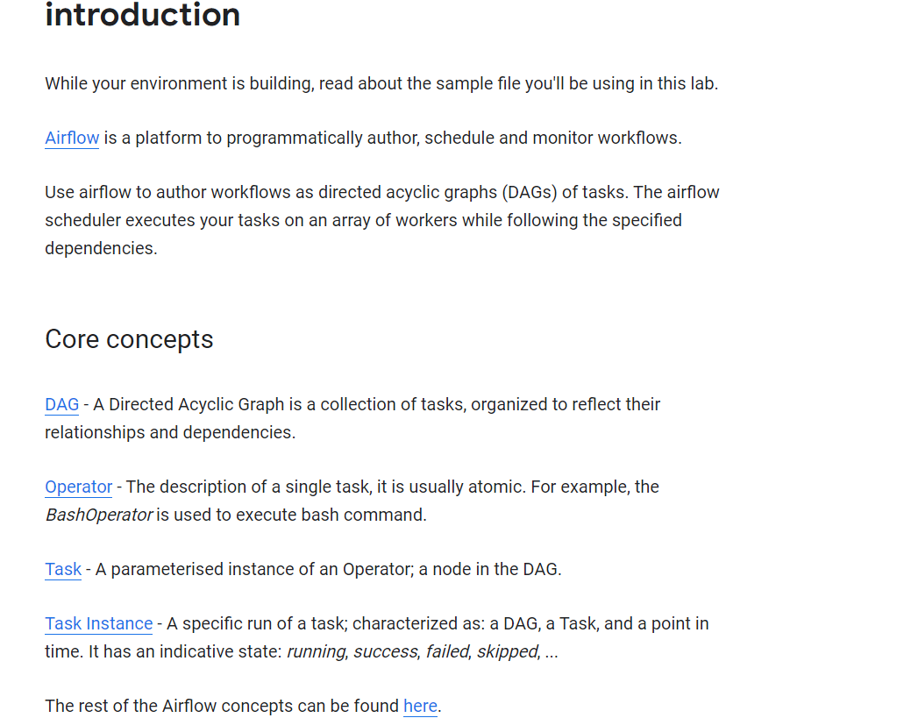

LAB

CREATE OR REPLACE TABLE taxirides.taxi_training_data_188

AS

SELECT pickup_datetime, pickup_longitude as pickuplon, pickup_latitude as pickuplat, dropoff_longitude as dropofflon,

dropoff_latitude as dropofflat, passenger_count as passengers, (tolls_amount + fare_amount) AS fare_amount_643

FROM 01WHERE

trip_distance >2

AND

fare_amount >= 2

AND

dropoff_latitude <> 0

AND

pickup_latitude <> 0

AND

pickup_longitude <> 0

AND

dropoff_longitude <> 0

AND

passenger_count >2

AND

RAND()< 0.001

CREATE MODEL:

CREATE OR REPLACE MODEL `taxirides.fare_model_733`

OPTIONS

(

model_type='linear_reg',

labels = ['fare_amount_643']

)

AS

#standardSQL

SELECT

  *

FROM

  # features

  (SELECT

      * EXCEPT(pickuplon, pickuplat, dropofflat, dropofflon), ST_Distance(ST_GeogPoint(pickuplon, pickuplat), ST_GeogPoint(dropofflon, dropofflat)) AS euclidean

  FROM

    `taxirides.taxi_training_data_188`

  );

EVALUATE MODEL/